# READ ME

## Dependencies

Need to install dependencies - It can be found on the "Dependencies" folder.

1. On Eclipse Project Explorer, right click on **Project name**.
2. Select **Build Path** -> **Configure Build Path**.  
   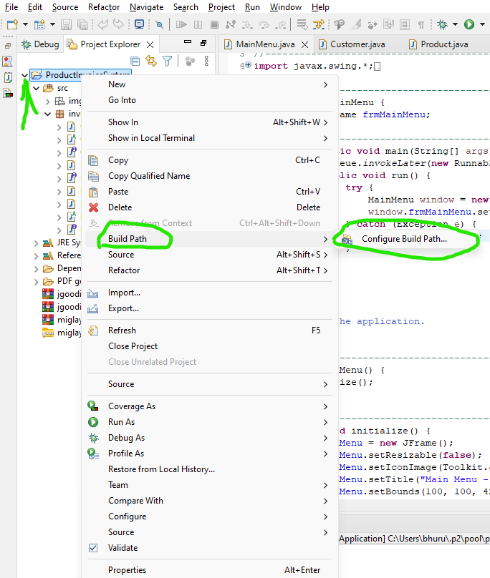
3. Under **Libraries**, **Add External JARs** to **Classpath**: (Download the JAR from Google)  
   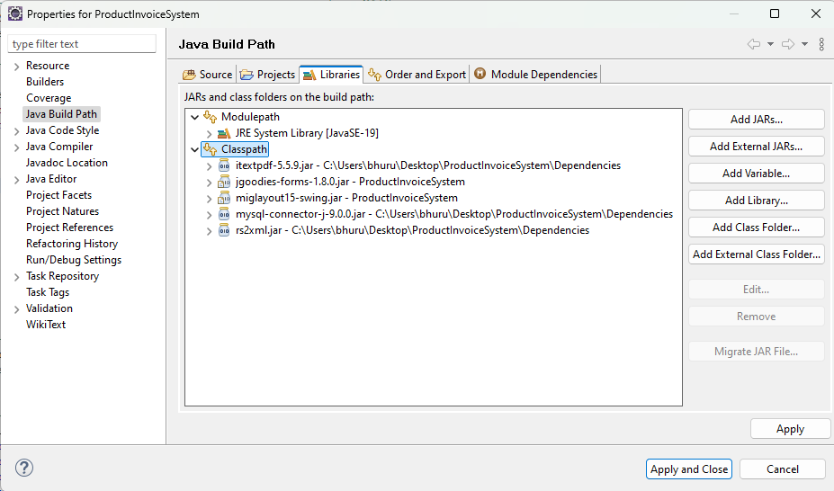

## Database File

Import “**product_invoicing.sql.gz**” file in XAMPP. (Location: Folder Dependencies -> Database XAMPP import)